End-point Assessment Appeals and Complaints
Policy & Procedures
October 2026 v4

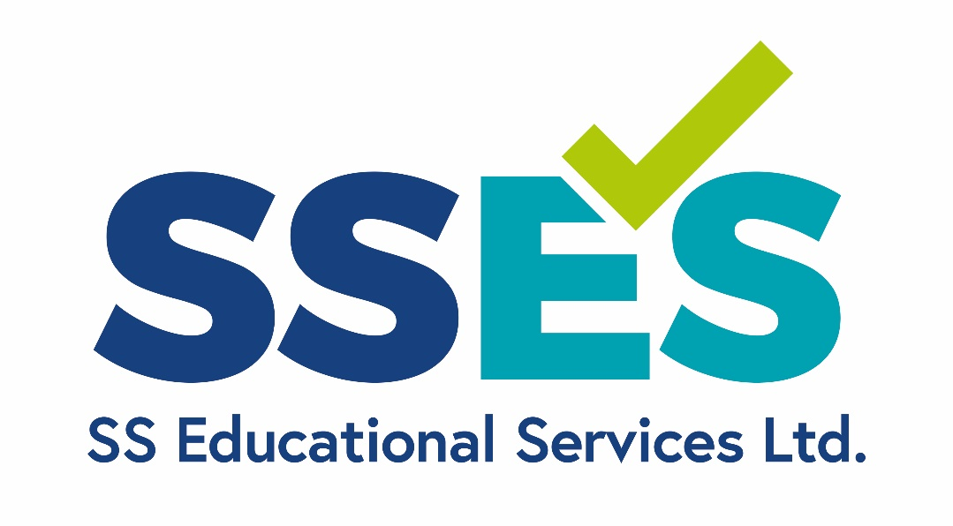

Contents
1. Introduction 4
2. PART 1 - COMPLAINTS 4
Making a Complaint 5
Complaint Investigation and Outcome 5
3. PART 2 - Appeals 6
Submitting an Appeal 7
Investigating the Appeal – Stage 1 7
Investigating the Appeal – Stage 2 8
4. Fees 10
5. Notifications from the Regulator and notifying other AOs 11
6. Changes to the Appeals and Complaints Policy 11
7. APPENDIX A 12

Version Control
Version Number | Date | Record of Changes
4 | October 2026 | Audit for any updates since March 2024
3 | March 2024 | Clearer segregation of appeals and complaints, with more detail added about the investigation processes
2 | 20th October 2022
1 | 15th Sept 2019 | First version

Introduction
The purpose of this policy is to make sure that Apprentices, and their employers or training providers, staff (including contractors), and stakeholders know how they can make a complaint about our end-point assessment service or an appeal about a decision made by SSES.
This policy covers:
- Complaints about the end-point assessment process, service or staff of SSES;
- Appeals about assessment results;
- Appeals about the outcome of reasonable adjustment or special considerations application;
- Appeals about the investigation outcome following malpractice or maladministration investigation;
- Appeals about the outcome of a complaint investigation;
All enquiries, complaints and appeals will be handled with an appropriate level of confidentiality and information released only to those who need it for the purposes of investigating or responding to the enquiry, complaint, or appeal. All enquiries, complaints and appeals will be dealt in a professional, and courteous manner by a skilled and competent expert that has no conflict of interest in the appeal or complaint being made, or the resulting investigation. Any individual involved in reviewing a complaint or appeal must declare any actual, potential or perceived conflict of interest before participating in the investigation.
All personal data will be processed in accordance with UK GDPR, the Data Protection Act 2018 and SSES Data Protection policies.
SSES will ensure that no individual is disadvantaged when accessing the complaints or appeals process on the grounds of a protected characteristic as defined under the Equality Act 2010.

PART 1 - COMPLAINTS
A complaint may relate to:
- The quality and standard of the EPA service
- The quality of facilities for EPA
- Treatment by, attitude of or behaviour of a SSES Independent End-Point Assessor or member of staff
- The failure of SSES EPA staff to follow an appropriate policies or processes

Making a Complaint
Complaints must be made within 20 days of the of the incident/matter subject to the complaint and must include the following details:
- A full description of the complaint (including the activity/subject matter, location, dates and times if known)
- Any names of the person/persons that have been involved so far, or any investigations that have already taken place
- Copies of any documents relating to the complaint
Whistleblowing
Sometimes a complainant will wish to remain anonymous. Although it is always preferable to reveal your identity and contact details to us, if you are concerned about possible adverse consequences, you may request us not to divulge your identity. If it helps to reassure you on this point, we will, where appropriate, maintain your identity. However, depending on the seriousness of the incident and if other parties become involved, e.g. police, we will have a legal obligation to disclose your identity. Whilst we are prepared to investigate issues which are reported to us anonymously, we shall always try to confirm a complaint by means of a separate investigation, before taking up the matter with those to whom the complaint relates. SSES will manage whistleblowing disclosures in accordance with the Public Interest Disclosure Act 1998 (as amended), current whistleblowing legislation, and relevant regulatory guidance
Complaints must be submitted to: contact@sseducationalservices.co.uk with the subject heading “complaint”.

Complaint Investigation and Outcome
SSES will acknowledge receipt within 5 working days, and assign an investigator who is independent of the matter subject to the complaint, who does not have a personal interest in the outcome, and has skills and/or been trained in complaints handling
An investigation will be carried out over a maximum period of 15 working days. However, if the complaint is more complex or involves anyone who is not available at the time, or relies on awaiting further information or evidence from the complainant or a third party, we may extend the timeframe, and will notify the complainant accordingly. The nature of the investigation will depend on the nature of the complaint but may include interviews and, documentation reviews
The investigation will be written into a formal report and notified to the SSES responsible officer and complainant. The results of the investigation will be:
- Complaint upheld or partially upheld
- Complaint rejected
In all cases the report will detail the reasons. Where a complaint has been rejected the complainant has a right to appeal.
The outcome will be recorded on our complaints log and will be used to support ongoing monitoring and continuous improvement.
Where a complaint is upheld, or partially upheld, we will take the following actions:
- Identify if any other Apprentices have been affected
- Notify Ofqual if there has been an adverse effect on the Apprentice, or there may be adverse effects on other Apprentices, alongside an associated action plan, with mitigation and monitoring activities.
- If the complaint has resulted in a result being incorrect SSES will notify both the DfE Apprenticeship service and Ofqual
- Amend, where required, policies, systems, or procedures so that the mistake/error cannot be repeated
- Update and/or provide additional staff training.

PART 2 - Appeals
An appeal is the process through which an appellant can dispute that SSES:
- has failed to apply procedures consistently, or
- has failed to follow its procedures properly and fairly, or
- has failed to take account of relevant information/evidence, or
- that has reached decisions that are disproportionate
Appeals may be made against:
- assessment results;
- the outcome of reasonable adjustment or special considerations application;
- the investigation outcome following malpractice or maladministration investigation;
- the outcome of a complaint investigation;
When appealing results, appellants must be aware that results can remain the same, go down, or go up as a result of an investigation following an appeal.

Submitting an Appeal
If an employer appeals on behalf of a Apprentice they must ensure that they have discussed the matter with the Apprentice(s), and captured their approval to submit on their behalf, before the appeal is made
Appeals must be submitted, using the template in appendix A, to: contact@sseducationalservices.co.uk with the subject heading “Appeal”, within 10 working days of notification of a decision:
- the issuing of assessment results,
- the outcome of reasonable adjustments or special considerations requests
- the outcome of investigations into maladministration / malpractice
- the outcome of investigations into complaints
SSES will acknowledge receipt of the appeal within 5 working days.
An appellant is not permitted to submit new material as part of their appeal.

Investigating the Appeal – Stage 1
The first stage will be to undertake an internal, independent, investigation into the appeal
The appeal will be allocated to a member of staff that has not been involved in the original decision and who does not have a personal interest in the outcome. However, they will be experienced in all SSES processes, policies, and procedures, have operational experience in the occupational sector to which the appeal relates, and, for results related appeals, will hold assessment qualifications. Subject to no conflict of interest we expect this person to be the Chief Executive Officer.
They will check the end-point paperwork for accuracy and completeness and that SSES has applied procedures consistently, properly and fairly. Throughout the investigation the Critical Friend on the Board of SSES will be responsible for overseeing the work of the investigation team to ensure that due process is being followed and appropriate evidence has been gathered and reviewed.
The investigation will be completed within 10 working days at which point SSES will inform the appellant of its decision either to:
- Amend the original decision in light of the rationale/evidence provided in the appeal; or
- Confirm the original decision stands and the complainant will decide if they wish to proceed to a stage 2 appeal
The outcome will be recorded on our appeals log, and will be used to support ongoing monitoring and continuous improvement.
The appellant has a period of 5 working days after the decision to either withdraw their appeal or to request to progress to a stage 2 appeal.
Where the appeal has been accepted, we will carry out an internal investigation to identify if any other Apprentices have been affected, learn lessons and take actions, such as procedural updates and internal training. Where required, we will also notify the regulator and the DfE Apprenticeship Service.
If the accepted appeal means that re-assessments need to be arranged, these will be arranged and managed by the chief administration manager over a period of 2 weeks.

Investigating the Appeal – Stage 2
SSES will arrange for an appeals panel to be held within 15 working days of the completion of the stage 1 appeal. This time frame may need to be extended if needed, and if this is the case all parties will be informed in writing.
The Appeals panel will consist of at least 2 people, with and independent chair, who:
- collectively have knowledge, experience and competence in the occupation, assessment process and investigative skills
- will not have a personal interest in the outcome of the appeal
- will not have been involved in the original decision or stage 1 appeal
The Chair of the appeals panel will be independent from all parties (employer, training provider, Apprentice, and SSES), and will be competent in the matter subject to appeal. All members of the panel will be checked for potential or actual conflicts of interest before being accepted onto the panel. The chair will make the decision on the appeal. The appeals panel will review all evidence, and may request to speak to or attendance from:
- The appellant, the employer or training provider
- those involved in making the original decisions.
The Appeals panel will establish whether our policies and procedures were correctly followed, that decisions were proportionate, and that all information presented at the time of the original decision was taken into account.
The chair’s decision is final and will be communicated in full to the appellant.
The outcome will be recorded on our appeals log and will be used to support ongoing monitoring and continuous improvement.
Should the appellant remain dissatisfied after fully exhausting our appeals process, they may wish to contact the regulator Ofqual. However, Ofqual will only consider whether the due process has been followed by SSES in considering the appeal.
Enquiries: 0300 303 3344 (the phone line is open on weekdays from 09:00 to 17:00)
Complaints: https://submit.forms.service.gov.uk/form/6208/make-a-complaint/MbaJgQQx
Malpractice and fraud reporting: https://submit.forms.service.gov.uk/form/6275/report-a-concern-of-malpractice-qualification-fraud-or-wrongdoing-whistleblowing/xhddd3GJ

Fees
Please find listed below any fees for appeals, which will be returned if the appeal is upheld.
- Assessment decision - £100
- Maladministration decision - £100
- Reasonable adjustment decision - £100
- Special consideration decision - £100
- Malpractice decision - £200
Fees will not apply where the appellant can demonstrate financial hardship or where the appeal relates to accessibility, discrimination or safeguarding concerns.

Notifications from the Regulator and notifying other AOs
Where SSES has been notified by Ofqual of failures that have been discovered in the assessment process of another awarding organisation, because of appeals or complaints, the responsible officer at SSES will review whether or not a similar failure could affect our own assessment process, and take appropriate action, notifying the regulator of our actions.
Should an appeal or complaint lead to an investigation into malpractice or maladministration under the malpractice of maladministration policy, and malpractice or maladministration is proven SSES will notify Ofqual and, under Condition A8.7b notify any other affected awarding organisation. The responsible officer with the governing body will identify other awarding organisations that may be affected, most likely to be those awarding organisations delivering the same qualification.

Changes to the Appeals and Complaints Policy
This policy, and any supporting documentation, is reviewed annually. However, at any period between the reviewing cycle, the policy, and/or any supporting documentation, may be amended or updated, following an investigation or legislative changes.
If you have any questions regarding this policy, please e-mail contact@sseducationalservices.co.uk and your comments and/or concerns will be forwarded to the relevant individual/s.
Person Responsible for review: Chief Administration Manager
This Policy has been agreed by: Critical Friend

APPENDIX A

Please complete this form if you wish to log an appeal or make a complaint.
Appeals and complaints may be submitted by email or in alternative formats where required as a reasonable adjustment.
Employer/Provider:
Contact Name:
Telephone No.:
Email:
Standard:
Name of the appellant:
Name of the Apprentice:
Type of Appeal/ Complaint:
Date/s:
Details of the Appeal / Complaint: (box will expand as necessary)

By submitting this form, I agree to pay the appeals fee as stated in the SSES Appeals Policy.
I confirm that the Apprentice is aware of this appeal and is supporting the logging of a complaint.
Name:
Company:
Signed:
Date:

