Conflict of Interest
Policy & Procedure
October 2026 v4

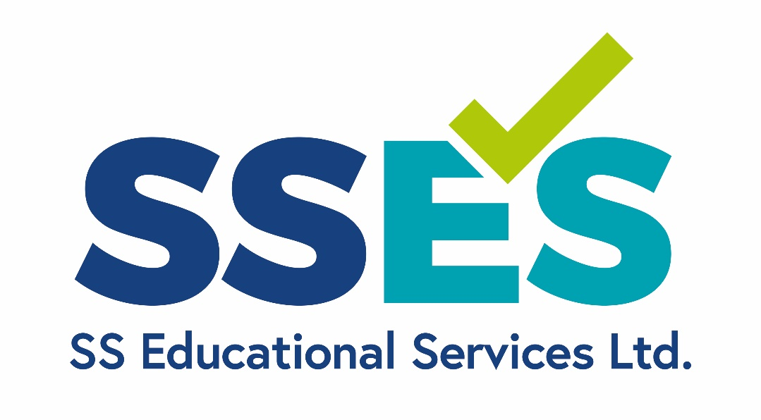

Contents
1. Introduction and Scope 4
2. Definition 4
Examples of Conflicts of Interest 5
3. Methods to Minimise the Risk of Conflict of Interest 6
4. Responsibilities and Process 6
5. Investigating Breaches of Conflicts of Interest 8
6. External Notification 8
7. Confidentiality 8
8. Record Keeping 9
9. Policy and Procedure Review 10
10. APPENDIX A 11
11. APPENDIX B 12
12. APPENDIX C 13

Version Control
Version Number | Date | Record of Changes
4 | October 2026 | Audit for any updates since March 2024
3 | March 2024 | Updates made to the declaration, and clarifications added to the procedure
2 | 24th October 2022
1 | 15th September 2019

Introduction and Scope
The purpose of this policy is to explain how and when SS Educational Services Ltd. (herein referred to as SSES) manage conflict of interest at an organisational and individual level (actual, perceived or potential, financial, or non-financial), ensuring that the integrity of the business and qualifications are maintained. It also ensures staff involved in investigating any matters, do so in a consistent process. This guidance acts to protect any individuals by minimising the possibility of a conflict of interest occurring.
This policy is designed to manage both actual and potential conflicts of interest in accordance with regulatory requirements.
It is a contractual obligation of all staff, both permanent and contract, that any actual or potential conflicts of interest are declared. This is carried out annually, and at any other occasion outside of this timeline when deemed necessary.
This policy applies to all employees, Independent End-Point Assessors, Board members and partner organisations that interact or potentially interact with the work of SSES’s End-Point Assessment (EPA). This includes individuals involved with any aspects of the creation, marketing, sales, distribution, marking or any other activity connected with tests and assessments, and supporting resources and services.
The individuals falling within the scope of this policy include directors, employees, contractors, home workers, agency workers and any associate staff, including assessment associates, verifiers/examiners and freelance staff.
All staff have a responsibility to be aware of the potential for a conflict of interest. It is the duty of the individual to disclose any actual or potential conflict of interest and to be aware of the process to be able to do this.
Non-adherence to this policy may in itself constitute investigations as part of our maladministration and malpractice policy.

Definition
For the purpose of this policy SSES has referred to the definition provided by Ofqual, the regulatory body. A conflict of interest exists in relation to SSES where:
- Its interests in any activity undertaken by it, on its behalf, or by a member of its Group have the potential to lead it to act contrary to its interests in the development, delivery and award of qualifications in accordance with its Conditions of Recognition
- A person who is connected to the development, delivery or award of qualifications by the awarding organisation has interests in any other activity which have the potential to lead that person to act contrary to his or her interests in that development, delivery or award in accordance with the awarding organisation’s Conditions of Recognition
- An informed and reasonable observer would conclude that either of these situations was the case.

SSES recognises three forms of conflict of interest:

Actual conflict

Potential conflict

Perceived conflict

SSES recognises that it cannot pre-empt when all conflicts of interest are likely to arise, or detail within its policy of every type of conflict of interest. As a result, this policy is designed to provide examples of Conflict of Interest, so as to identify Conflict of Interest before it happens, and the process to notify, investigate, mitigate, and manage Conflict of Interest where and when it is identified. Examples of Conflicts of Interest:
Conflicts of interest can arise in a variety of circumstances in relation to awarding activities. The list below includes examples, but is not definitive:
- An individual may be employed in one organisation involved in EPA and has links with and/or is employed in the same organisation as the learner, or has undertaken the on-programme delivery attached to the EPA
- An individual involved in EPA may be working for an organisation that is in direct competition with the organisation involved in on-programme delivery
- An Independent End-Point Assessor (IEPA) may become involved in an unexpected conflict of interest, such as arriving to carry out an EPA and discovering that the learner is known to them
- At both organisational and individual level, the official role of the individual/organisation undertaking the EPA has any other interests that may compromise their assessment decisions
- IEPAs having a close personal friendship, intimate relationship or familial relationship with a learner, or learners’ families, whilst being involved in decisions about the outcome of their qualification
- Using third party consultants to support developing question banks may lead to a consultant developing one set of questions and using the same set for multiple EPAOs.
- Using a consultant to support the design of End-Point Assessment materials that is working for a training provider delivering the standard could lead to bias in the materials created, and a risk to the confidentiality of assessment materials
Having a conflict of interest does not prohibit us from operating. However, some of the Ofqual Conditions do prohibit certain conflicts of interest in specific circumstances:
- Condition A8.3 prohibits anyone with a personal interest in the outcome of an investigation into potential malpractice from carrying out investigations of suspected or alleged malpractice
- Condition G4.6 prohibits anyone with a personal interest in the outcome of the investigation into potential breaches of confidentiality from carrying out investigations of suspected or alleged breaches of confidentiality
- Condition I1.2 prohibits anyone with a personal interest in the decision being appealed from taking decisions on that appeal.

Methods to Minimise the Risk of Conflict of Interest
SSES adopts a range of methods to minimise the risk of conflict of interest:
- None of the directors of SSES are directors of other companies, or have financial interests in other companies
- SSES does not deliver apprenticeship training
- SSES directly employs its assessment developers, as opposed to using freelance/contracted developers/assessors. However, should third party developers be required they are subject to a robust recruitment and contracting process which includes checks for integrity and conflicts of interest
- SSES has a robust recruitment and contracting process which includes checks for integrity and conflicts of interest for any third party assessors or quality assurers
- All staff are trained on conflicts of interest at induction
- All staff, regardless of their duties within the end-point assessment service, must complete annual conflict of interest declarations (COIDS) – appendix A.
  - These declarations must also be updated mid-year, should circumstances change
- Board members will declare conflicts at the start of each meeting and these will be formally recorded in meeting minutes.
- All assessors receive the names of the learner prior to being scheduled to deliver assessment, and must complete a COID before being approved to assess that learner
- All staff involved in malpractice/maladministration, appeals, complaints investigations must complete a COIDS before being authorised to be involved
- If a quality assurer is also an assessor, they are forbidden from quality assuring their own work.
All declarations will be processed in accordance with the data protection principles as set out in the UK GDPR and the Data Protection Act 2018
Responsibilities and Process
The ultimate responsibility for the Conflict-of-Interest Policy, dissemination of the policy, and management of actual and potential conflicts of interests rests with the Chief Administrative Manager, with oversight from the Critical Friend (CF).
- The SSES Critical Friend (CF) is not employed by SSES and has no personal or financial interest in the business
- The Chief Administrative Manager (CAM) is the Reporting Officer, responsible for operating the conflict of interest process from issuing and checking declarations through to escalation to the CF and the board of governance:
  - All declarations will be acknowledged within 2 working days
  - Most situations require no further action once reported, however, it will be recorded as a minimum
  - Where potential or actual conflicts have been declared a report will be raised and issued to the CF for further scrutiny
  - A decision will be made within 10 days of submission of the declaration, shared with the individual and recorded on the conflict of interest register
  - The register will be reviewed at each board of governance meeting to support conflict of interest management and future scheduling
Decisions may be timebound, and may include:
- No action required – after investigation it does not present a conflict of interest
- removing the individual from a particular assessment or investigation and referring the activity to another assessor / investigator with no conflict of interest
- Re-organising assessment activities or functions
- Increased assessor sampling/monitoring
- Removal of developer from developing assessment materials
Once a decision has been made based on the detail / content of the declaration, the individual can accept the decision, in which case there would be no further action. Or, they can contest the decision and ask for a formal review of the Conflict of Interest. The CAM acknowledges receipt within 2 working days and sources an Independent Panel Adviser (IPA) from outside of SSES. The IPA will inspect the documentation gathered for Stage 1 and request any further information that they feel will aid their investigation in order to make a final decision as to whether the original decision to manage conflicts of interest remains. It is important to note that the review relates to decisions made around a declaration before any work is undertaken. The process for investigating undeclared conflicts of interest is covered through our malpractice and maladministration policy and procedure.

Investigating Breaches of Conflicts of Interest
Alleged breaches of conflict of interest may be identified and/or reported via whistleblowing, complaints, or via quality assurance sampling and observation activities. Appendix B contains a template that can be used to report concerns.
All allegations of breaches must be reported to the CAM, or the CF if the report relates to a director of SSES.
Investigations, any required sanctions, will take place in accordance with our Malpractice and maladministration policy.

External Notification
We are aware that customers (employers and training providers) often work with more than one End-Point Assessment Organisation (EPAO) in, and that therefore more than one EPAO may be at risk when things go wrong. Our regulator has outlined some specific conditions that we must meet to protect the integrity across the sector. This includes the requirement that where certain things are identified (such as malpractice), or certain actions taken (such as when sanctions are applied), the Regulators and other relevant EPAOs who may be affected must be informed.

Confidentiality
All declarations will be processed in accordance with the data protection principles as set out in the UK GDPR and the Data Protection Act 2018.
As far as possible all information shared is kept confidential, in line with our Confidentiality Policy and current GDPR/DPP. However, we may be required to do so if the outcome demonstrates a serious Conflict of Interest which involves informing external organisation, including (but not exclusively) Ofqual and any other relevant regulatory, funding or oversight body.
The Board is advised of the case at the next meeting, unless there had been an Emergency Board Meeting, in order to self-evaluate and to analyse likelihood of repeat of incident, and how that could be avoided

Record Keeping
SSES retains all annual declarations for the duration that the employee works for SSES, and then 6 years after.
Any allegation record of Conflict of Interest is retained for 6 years, including the initial report, any investigation, the outcome, and if necessary, actions taken to mitigate any adverse effects.

Policy and Procedure Review
This policy, and any supporting documentation, is reviewed annually. However, at any period between the reviewing cycle, the policy, and/or any supporting documentation, may be amended or updated, following an investigation or legislative changes.
If you have any questions regarding this policy please e-mail contact@sseducationalservices.co.uk where your comments and/or concerns will be forwarded to the relevant individual.
Person Responsible for review: Chief Administration Manager
This Policy has been agreed by: Critical Friend

APPENDIX A
Conflict of Interest Declaration Statement
SS Educational Services have a legal and moral obligation to ensure that any potential conflict of interest is recognised and dealt with appropriately. A non-definitive list of the types of conflict is included within the main policy, which must be read in conjunction with this declaration.

Any individual/s that are involved with SSES must sign a declaration regarding any conflicts of interest, this is reviewed annually. A potential conflict of interest would not necessarily prevent the individual from being involved with SSES, but it would allow SSES to make changes to plans to prevent a conflict changing from potential to actual. They must further advise their line manager if they feel there is a potential conflict of interest between the annual declarations.

NAME
DATE
ROLE in SSES*
*for example, IEPA, IQA, developer, investigator, board member
Do you have any potential or actual conflicts of interest to declare? (if you are unsure it is best to disclose) YES / NO
If yes, please detail:
Declaration
I declare that this is a true and accurate reflection of my potential or actual conflicts of interest and I understand it is my duty to advise SSES if any details within this declaration change |  | Signature:

APPENDIX B
Conflict of Interest Whistleblowing Form
This form is to be used if you have a Conflict of Interest concern regarding another SSES member of personnel. Once completed you can either:
- Email to contact@sseducationalservices.co.uk OR
- Print out and send to the Critical Friend, Board Member, marking the envelope Strictly Private and Confidential
Contact Name:
Telephone No.:
Email:
Name of SSES personnel:
Is it a potential conflict of interest or an actual conflict of interest?
Has the activity to which it relates already happened?
What does it potentially affect – assessment design, confidentiality of materials, assessment delivery, quality assurance?
Details of the activity and Conflict of Interest: | (Please give as much information as possible, the box will expand as necessary)

Signed:____________________________________
Date: _____________________________________
Please refer to the Conflict of Interest Policy for the procedure following a declaration.

APPENDIX C
CONFLICT OF INTEREST LOG
To be completed at the end of an investigation, and all evidence stored in the ‘Conflict of Interest’ Folder
DATE | NAME | REPORTED CoI | U | F | Actions Taken | Outcome

U = Unfounded
F = Founded

