End-point Assessment Malpractice and Maladministration
Policy & Procedures
October 2026 v4

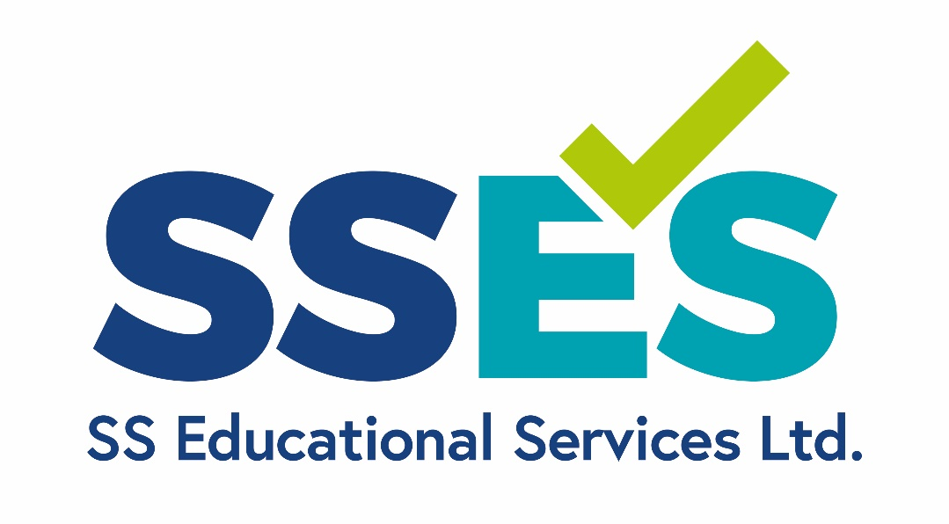

Contents
1. Introduction 4
2. Definition of Maladministration 4
3. Definition of Malpractice 4
4. Reducing Malpractice and Maladministration (Adverse Effects) 5
5. Confidentiality and Whistle Blowing 6
6. Reporting and Investigation Overview 6
7. Notifying Relevant Parties 8
8. Procedure 8
9. Investigation Report 8
10. Investigation Outcomes 9
11. Appeals 9
12. Records 9
13. Policy and Procedure Review 9
14. APPENDIX A 11
15. APPENDIX C 13
16. APPENDIX D PROCEDURE TO FOLLOW ONCE A COMPLETED APPENDIX C HAS BEEN RECEIVED: 14
17. APPENDIX E 16
18. APPENDIX F 17
19. APPENDIX G 19
20. APPENDIX H………………………………………………………………………………………………………………………………………… 20
Version Control
Version Number | Date | Record of Changes
4 | October 2026 | Audit for any updates since March 2024
3 | January 2024
2 | 15th November 2022
1 | 20th September 2019

Introduction
The purpose of this policy is to explain how and when our organisation may have to refer to policy for Malpractice and Maladministration. It also ensures staff involved in investigating any matters do so in a consistent process. SS Educational Services Ltd. (herein referred to as SSES) have policies and procedures in place to minimise the possibility of malpractice and maladministration occurring, specifically the Conflict-of-Interest Policy
This policy applies across the entire lifecycle of a qualification from the decision to deliver an assessment, through its design/development and across its delivery / award, and into quality assurance and continuous improvement. It is important that staff involved in the management, assessment and quality assurance of the qualifications, and the learners, are fully aware of the contents of the policy and that SSES has arrangements in place to prevent and investigate instances of malpractice and maladministration.

Definition of Maladministration
The qualifications regulator Ofqual provides guidance on the definition of maladministration:
“Maladministration generally covers mistakes or poor process where there has been no intention on the part of the person responsible to do any harm. It may involve some degree of incompetence or ineptitude, or may result from carelessness or inexperience.”
The following are examples of maladministration:
- avoidable delay;
- mistakes arising from inattention;
- faulty procedures;
- failure to follow correct procedures;
- poor record keeping;
- inadvertent failure to take action;
- poor communication; and
  - inadvertently giving misleading or inadequate information

Definition of Malpractice
The qualifications regulator Ofqual provides guidance on the definition of malpractice:
“malpractice will generally involve some form of intent. It may also include circumstances where an individual has been negligent or reckless as to the consequences of their actions. Malpractice could comprise of a conscious decision to do anything covered in the maladministration list above. Bias or discrimination could also lead to malpractice”
Based on this guidance, SSES define malpractice as any deliberate activity, neglect, default or other practice that compromises the integrity of the internal or external assessment process and/or validity of certificates of a qualification awarded by SSES. It covers the deliberate actions, neglect, default or other practice that compromises, or could compromise the following:
- The assessment process
- Integrity of a regulated qualification
- The validity of a result or certificate
- The qualification of the wider qualification’s community.
Examples can be found in Appendix A.

Reducing Malpractice and Maladministration (Adverse Effects)
Incidents of malpractice / maladministration can lead to a range of adverse effects, such as learners being disadvantaged, costly and time-consuming investigations, reputational damage to SSES, employers, training providers, and the apprenticeship brand. It is therefore important to prevent malpractice / maladministration from occurring whenever possible. Where it is not possible to prevent this, investigations will determine whether an actual or potential Adverse Effect has occurred and establish actions required to correct, mitigate and prevent recurrence.
Although it is not possible to eradicate either Malpractice or Maladministration completely, SSES have in place practices and processes that limit the possibility, including:
- When a Learner takes their End-Point Assessment, they have to produce in-date photo identity before the assessment commences, or they will not be able to complete the End-Point Assessment
- As part of the Gateway, we have a document ‘Statement of Authenticity’ in which we ask the Learner and their employer to sign and state that the work produced is the Learner’s own work
- We complete a check at the start of the assessments to ensure that the Learner only brings into the End-Point Assessment any documentation agreed in an assessment plan, (e.g., the Level 3 Early Years Educator allows the portfolio of evidence to be available during the professional discussion)
- We use a secure management information system, SkilSure
- All documentation is stored securely and accessible in a ‘need to know’ basis
- All assessors are trained in their role and receive guidance, and set templates to ensure consistency of delivery
- All employees sign an annual declaration for Conflict of Interest, and are declared to update the declarations mid-year if their circumstances change
- Conflict of Interest is also checked at each assessment
- SSES has a comprehensive induction to ensure employees are aware of the processes and procedures
- SSES carry out detailed Internal Quality Assurance and maintain appropriate records.
- All end-point assessments are subject to Internal Quality Assurance enabling the opportunity to notice any malpractice and maladministration.

Confidentiality and Whistle Blowing
Whistle Blowing is a term used to refer to an individual who discloses information relating to actual malpractice or maladministration and/or the covering up of such practices. In certain circumstances whistle blowers have protection in law under the Public Interest Disclosure Act.
If the individual decides to raise their concerns internally, then they need to complete Appendix C, which can then be returned to either contact@sseducationalservices.co.uk . Alternatively, it can be printed off and sent Strictly Private and Confidential to the Critical Friend on the Board, c/o the Head Office of SSES.
Ofqual states that staff who wish to make a whistle blowing disclosure to someone outside their organisation, they should normally do so to the relevant awarding organisation, Ofqual (England). SSES will always endeavour to keep a whistleblower’s identity confidential where asked to do so, although we cannot guarantee this and we may need to disclose your identity to the police or other law enforcement agencies, the courts, or another person to whom we are required by law to disclose your identity. A whistleblower should also recognise that he or she may be identifiable by others due to the nature, or circumstances of the disclosure.
Whilst we will consider investigating issues which are reported to us anonymously, we shall always try to confirm an allegation by means of a separate investigation before taking up the matter with those to whom the allegation relates. It is not always possible to investigate, or substantiate anonymous disclosures.

Reporting and Investigation Overview
Malpractice / maladministration can be identified, alleged, or reported by anyone (staff member, contractor, employer, provider, apprentice, third party) at any stage of the end-point assessment service (design, delivery, award, quality assurance).
Whether intentional or not, it is necessary to investigate any suspected instances of malpractice or maladministration, to protect the integrity of the qualification and to identify any wider lessons to be learned.

Terms of Reference

* We recognise that staff, learners, and customers, can be responsible for malpractice and maladministration, and as such we consider potential conflicts of interest and expertise/competence when reviewing the allegation, assigning an investigator and examining the evidence. At all times we will ensure that the member of staff appointed to lead the investigation has the appropriate level of training and has had no previous involvement or personal interest in the matter.
** Where a member of staff is under investigation we may suspend, or relocate them to other duties, until the investigation is complete. Where the allegation is against a Learner, we reserve the right to withhold their certificate until the investigation is complete. SSES retain the right to contact the police if fraud is suspected and / or identified.
Any concern identified during a malpractice or maladministration investigation that relates to safeguarding, welfare or criminal activity will be referred immediately to the appropriate safeguarding lead and external authorities where required.

Notifying Relevant Parties
SSES will notify Ofqual and any other relevant regulatory, funding or oversight body where required. if we believe there may have been an incident of Malpractice or Maladministration which could invalidate the award of the apprenticeship.
Where the allegation may affect another organisation, we will also inform them if we do not know the details of organisations that might be affected, SSES will notify Ofqual and any other relevant regulatory, funding or oversight body where required.

Procedure
SSES follow the timeline and procedure set out in Appendix D.

Investigation Report
The fundamental principle of all investigations is to conduct them in a fair, reasonable and legal manner, ensuring that all relevant evidence is considered without bias. In doing so investigations will be underpinned by terms of reference and based around the following broad objectives:
- To establish the facts relating to allegations/complaints in order to determine whether any irregularities have occurred
- To identify the cause of the irregularities and those involved
- To establish the scale of the irregularities and whether other qualifications may be affected
- To evaluate any action already taken
- To determine whether remedial action is required to reduce the risk to current registered learners and to preserve the integrity of the qualification
- To ascertain whether any action is required in respect of certificates already issued
- To identify any adverse patterns or trends.

Investigation Outcomes
If the investigation confirms that employee, or learner malpractice or maladministration has taken place, which has created an adverse effect, we will take actions to ensure there is not a repeat of the concern and take remedial action against the adverse effect. This may involve changes to policies, additional staff training and carry out further investigations. The action will depend upon the risk to the integrity of the service, and public confidence in the qualification.
Decisions will be reached based on the probabilities using available evidence.
After an investigation, we shall produce a draft report for the parties concerned to check the factual accuracy of the report. Any subsequent amendments will be agreed between the parties concerned and SSES. We shall make the final report available to the parties concerned and to the regulators and other external agencies as required.
If it was an independent / third party that notified us of the suspected or actual incident of malpractice, we may also inform them of the outcome, normally within 10 working days of making our decision. In doing so we may withhold some details if to disclose such information would breach a duty of confidentiality, GDPR or any other legal duty.
If it is an internal investigation against a member of our staff, the report will be agreed by the CEO with the relevant internal managers and HR. If appropriate, internal disciplinary procedures will be implemented.
Sanctions may include:
For learners – EPA result withheld; EPA result voided; requirement to re-sit assessment; disqualification from assessment.
For staff / self-employed contractors – retaining; enhanced monitoring; suspension; removal from assessor duties; disciplinary action.

Appeals
Should an employee or learner wish to appeal against any action to be taken following an investigation, please refer to our Appeals Policy.

Records
All records pertaining to the allegation, subsequent investigation and outcome must be retained by SSES. This includes all statements from anyone involved, panel meeting minutes and any actions taken in relation to the individual concerned, as well as any remedial action taken. Records are kept for a maximum of 6 years.
All documentation and correspondence will be processed ‘fairly and lawfully’, and in accordance with the UK GDPR and the Data Protection Act 2018.

Policy and Procedure Review
This policy, and any supporting documentation, is reviewed annually. However, at any period between the reviewing cycle, the policy, and/or any supporting documentation, may be amended or updated, following an investigation or legislative changes.
If you have any questions regarding this policy please e-mail contact@sseducationalservices.co.uk where your comments and/or concerns will be forwarded to the relevant individual.
Person Responsible for review: Chief Administration Manager
This Policy has been agreed by: Critical Friend

APPENDIX A
Examples of Malpractice (please note this list is not exhaustive):
- Denial of access to premises, records, information, learners and personnel to any authorised representative and/or the regulatory authorities
- Deliberate misuse of our logo, brand and name
- Deliberate failure to carry out internal assessment, internal moderation or internal quality assurance monitoring in accordance with our requirements
- Undeclared conflicts of interest
- Submission of falsified, fabricated or incorrect gateway evidence
- The unauthorised use of inappropriate materials/equipment in assessment settings, e.g., mobile phones
- A loss, theft of, or a breach of confidentiality in, any assessment materials
- Insecure storage of assessment materials
- Inappropriate circulation/distribution of assessment materials
- Unauthorised amendment, copying or distributing of assessment papers/materials
- Impersonation (getting another person to take assessments on their behalf)
- Inappropriate assistance/support to learners by SSES employees, e.g., unfairly helping them to pass a unit or qualification
- Deliberate failure to adhere to, or to circumnavigate, the requirements of our Reasonable Adjustments and Special Considerations Policy
- Plagiarism by learners
- Cheating by learners
- Personation, assuming the identity of another learner or having someone assume their identity during an assessment
- Collusion or permitting collusion in assessments
- Deliberate contravention by learners of the assessment arrangements we specify for our qualifications
- Fraudulent claim for certificates and/or deliberate submission of false information to gain a qualification
- False records
- Deliberate failure to adhere to our learner registration and certification procedures
- Deliberate failure to maintain appropriate auditable records, e.g., certification claims and/or forgery of evidence
- Learners still working towards qualification after certification claims have been made
- Selling certificates for cash
- Selling papers/assessment details
- Extortion
- Fraud
- Threatening or abusive behaviour that threatens the safety of staff and/or is intended to put undue influence on the outcomes of an assessment/award.

APPENDIX B
Examples of Maladministration (please note this list is not exhaustive):
- Persistent failure to adhere to learner registration and certification procedures
- Persistent failure to adhere to registration approval criteria and/or qualification requirements
- Late learner registrations (both frequent and persistent)
- Unreasonable delays in responding to requests and/or communications from
- Inaccurate claim for certificates
- Late learner certification requests, e.g., beyond the certification end date for the qualification
- Failure to maintain appropriate auditable records, e.g., certification claims and/or forgery of evidence
- Withholding or the delaying of information, by deliberate act or omission, from us which is required to assure Ofqual and/or ESFA of SSES’s ability to deliver qualifications appropriately
- Misuse and/or misrepresentation of our logo and trademarks
- Poor administration arrangements and/or records
- Persistent mistakes in relation to our delivery arrangements
- Failure to adhere to, or to circumnavigate, the requirements of our Reasonable Adjustments and Special Considerations Policy

APPENDIX C
Please complete this form if you wish to log a concern regarding malpractice or maladministration and email to contact@sseducationalservices.co.uk Alternatively, if you prefer, send directly to the Critical Friend, Board Member, c/o the Head Office of SSES, marking the envelope Strictly Private and Confidential.
Employer/Provider:
Contact Name:
Telephone No.:
Email:
Standard/Service affected:
Name of Learner / SSES personnel
Date occurred:
Time:
Place:
Please circle as appropriate | *Malpractice OR *Maladministration
Details of the concern: (box will expand as necessary)

Name
Signed
Date

APPENDIX D
PROCEDURE TO FOLLOW ONCE A COMPLETED APPENDIX C HAS BEEN RECEIVED: | TICK
- The Assessment Team will send acknowledgement to the individual who completed an Incident Form within 2 working days.
- The Assessment Team will contact the Learner/employee and advise them of the allegation made against them. They will explain that policy is to complete an investigation within 10 working days. If, however, the Critical Friend is unavailable, they will give an amended timeline. The Learner/employee will have been informed of their individual responsibilities and rights.
- The concern is then handed over to the Quality and Compliance Manager (QCM) to lead the investigation, subject to checks for conflicts of interest. An alternative expert will be identified if the QCM has been involved or has a personal interest in the malpractice / maladministration being reported
- The QCM will initially invite the Learner/employee for an interview and explain the reason for the meeting via e-mail. The individual will be advised that they can bring along someone for support to the meeting. They will also be invited to give a written statement and will be provided with a copy of the Malpractice and Maladministration Policy and Procedures.
- During the meeting a member of either the Programme Support Team or Assessment Team will take minutes. Any evidence will be presented and the Learner/employee will have the opportunity to comment on the allegation. During the meeting the individual will be informed of the possible consequences should malpractice/maladministration be proven.
- After the meeting the QCM will review the evidence, follow up any evidence offered during the meeting and decide if there is a case for the Learner/employee to have a case to answer.
- If the QCM feels there is no need to pursue the matter, they will pass all the information to the Critical Friend to make an independent decision on the outcome. If they are in agreement then the Learner/employee, and the individual making the allegation, will be advised that no further action will be taken
- If the QCM feels there is a need to pursue the matter then SSES will notify Ofqual and any other relevant regulatory, funding or oversight body where required.
- The QCM will then organise a panel meeting with the Learner/employee. Three people need to attend and at least one must have no conflicting interest in the outcome. The panel can include:
  - Chairperson - Either the Critical Friend OR the Director of Quality –
  - Operations Director; Quality and Compliance Manager
- Both the CEO and the Chief Administrative Manager will not be involved in order to remain impartial should the Learner/employee appeal.
- The Learner/employee will be informed of the date, time and venue for the panel meeting. They will be advised they can bring a colleague, family member or friend to the meeting. This person can be supportive to the Learner/employee but cannot ask questions directly or offer information to the panel.
- The Panel will make a decision whenever possible within 10 working days, but will keep the Learner/Employer updated if investigations and outcome will take longer.
- Refer to Point 11 of this Policy for the next stage.

APPENDIX E
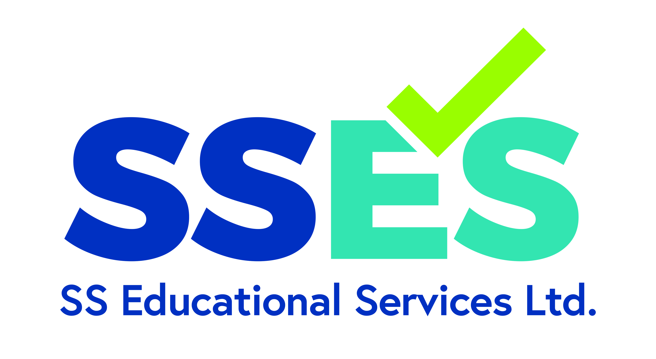
Notifying Relevant Parties – Complete where a significant allegation or actual/potential adverse effect requires notification to Ofqual or other relevant bodies.
EPAO Name | SS Educational Services Ltd.
Address | Castle Hill House, 12 Castle Hill, Windsor, Berkshire, SL4 1PD
Lead Investigator | TBC, Quality and Compliance Manager (QCM)
Conflict of Interest | There is no Conflict of Interest.  SSES will ensure that the QCM has not worked directly with the individual named in the allegation. The final decision will be made by the Critical Friend on the Board, who is not employed by SSES and has no Conflict of Interest.
Contact Email | compliance@sseducationalservices.co.uk
Type of incident | Malpractice | Maladministration
Date informed of alleged incident | Box will expand as needed
Date, time, venue of alleged incident | Box will expand as needed
Description of alleged incident | Box will expand as needed
Planned actions and timeline | Box will expand as needed

Name
Signed
Dated

APPENDIX F
Investigation Report Documentation – Part 1
EPAO Name | SS Educational Services Ltd.
Address | Castle Hill House, 12 Castle Hill, Windsor, Berkshire, SL4 1PD
Lead Investigator | TBC, Quality and Compliance Manager (QCM)
Conflict of Interest | Conflict of interest check completed and no actual, potential or perceived conflict identified.  The QCM has not worked directly with the individual named in the allegation. The final decision will be made by the Critical Friend on the Board, who is not employed by SSES and has no Conflict of Interest.
Contact Email | compliance@sseducationalservices.co.uk
Type of incident | Malpractice |  | Maladministration
Name of alleged individual | Box will expand as needed
Date informed of alleged incident | Box will expand as needed
Date, time, venue of alleged incident | Box will expand as needed
Description of alleged incident | Box will expand as needed
Give details of the evidence you have obtained during your investigation
Box will expand as needed
In presenting the findings to the Critical friend are you recommending? |  | NO FURTHER ACTION |  | FURTHER INVESTIGATION
Please explain your findings and the rationale
Box will expand as needed

Name
Signature
Date

Attached Evidence | TICK
Original Incident Report form
Minutes from first meeting
Written statement from Learner/employee
Other – please list and expand table as necessary

I agree with the decision | I disagree with the decision
NO FURTHER ACTION REQUIRED | FURTHER INVESTIGATION REQUIRED
Name (Critical Friend)
Signature
Date

APPENDIX G
Investigation Report Documentation – Part 2 To be used if the decision ‘Further Investigation’ was decided in Part 1.
To be completed by the Chair of the Panel Meeting – either the Critical Friend or an external individual specialising in EPAO investigations if the Critical Friend is unavailable
EPAO Name | SS Educational Services Ltd.
Address | Castle Hill House, 12 Castle Hill, Windsor, Berkshire, SL4 1PD
Lead Investigator | TBC from the options above
Conflict of Interest | Conflict of interest check completed and no actual, potential or perceived conflict identified.  The final decision will be made by an individual who is not employed by SSES and has no Conflict of Interest.
Contact Email | compliance@sseducationalservices.co.uk
Type of incident | Malpractice |  | Maladministration
Name of alleged individual
See Investigation Report Documentation – Part 1, for information on allegation
Date, time, venue of panel meeting
Attendees of Panel Meeting
Further evidence offered
Give details of the evidence you have obtained during your further investigations
Box will expand as needed
In presenting the findings to the Critical friend are you recommending? |  | NO FURTHER ACTION |  | FURTHER INVESTIGATION
Please explain your findings and the rationale
Box will expand as needed
If Malpractice/Maladministration has been identified please list actions below to prevent further incidents, and any remedial work needed for the adverse effect.
Box will expand as needed

Attached Evidence | TICK
Original Incident Report form
Minutes from Panel Meeting
Written statement from Learner/employee
Other – please list and expand table as necessary

Name (Chair of Governing Board)
Signature
Date

